State of the Alameda Creek Watershed Conference Agenda
May 5, 2022
9:00 Registration and Coffee/Tea/Morning Snack.
9:30 WELCOME
- Contra Costa and Alameda County Regional Priority Plan: A Wildfire Protection Plan for Open Spaces and Natural Resources
Ben Weise, Agriculture Conservation Manager, Contra Costa Resource Conservation District
- Using The Three E's to Address Illegal Dumping
Erin Armstrong - Special Assistant to Alameda County Supervisor Nate Miley
Ashley Strasburg - Constituent Liaison and Community Organizer for Alameda County Supervisor Nate Miley

Break & Raffle
- Water Operations and Fisheries Monitoring in Alameda and Calaveras Creeks
Randall Renn- Biologist, San Francisco Public Utilities Commission
11:30 Lunch & Photo Contest Voting
- Minute News
- Creekside Discoveries: Alameda Creek Public Education at Sunol Wilderness Preserve
Ashley Grenier, Supervising Naturalist
Kristina Parkison, Naturalist

- The Lower Alameda Creek Restoration Project, Sediment to the Sea
Sydney Temple P.E., Questa Engineering Corp.
Break & Raffle
- Fuels Management in Regional Parks: Creating Fire Resilient Parklands
Kristen Van Dam, Ecologist
3:00 Final Raffle
SCAN ME TO FILL OUT TODAY’S EVALUATION

THANK YOU TO OUR HOST
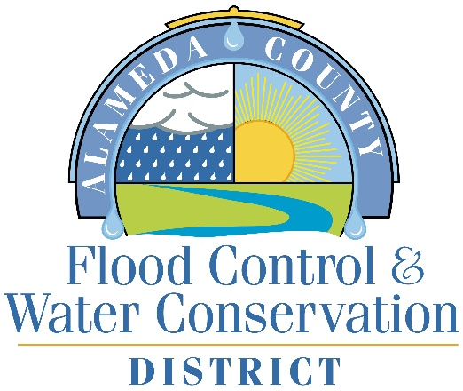

THANK YOU TO OUR PRESENTER SPONSOR
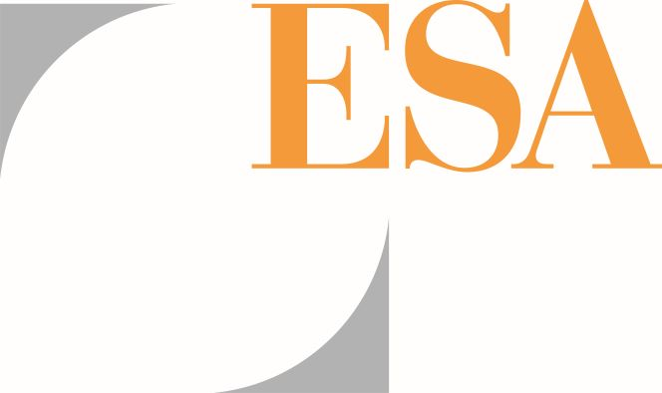

THANK YOU TO OUR HOSPITALITY SPONSORS
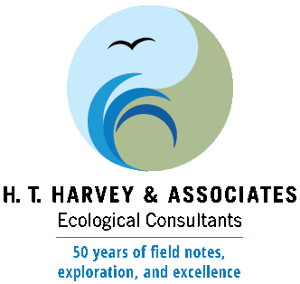

THANK YOU TO OUR PHOTO CONTEST SPONSOR
